**SIECA Gantry SITE SURVEY REPORT – Honduras/Nicaragua Border Guasaule Honduras.**

|  |  |
| --- | --- |
|  |  |

Author(s): Robert Grant,

Contributor(s): Oleg Iagounov, Carlos Roberto Mejia Henriquez <cmejia@sieca.int>

Reviewer(s): Jesper Boller, Simon Johansen

Filename: 077.200.295 Site Survey Report - Guasaule - Honduras

Status: Release: V5

Revision Date: 1/24/2019

|  |  |
| --- | --- |
|  |  |

THIS DOCUMENT CONTAINS INFORMATION PROPRIETARY TO LYNGSOE SYSTEMS AND MAY NOT BE REPRODUCED, DISCLOSED OR USED IN WHOLE OR PART WITHOUT THE EXPRESS WRITTEN PERMISSION OF LYNGSOE SYSTEMS LTD.

Revision History Table

Table 1. Revision History.

|  |  |
| --- | --- |
| Revision | Changes Since Previous Revision |
| 1 | This is the original release of the document. |
| 2 | Changes made based on feedback from SIECA |
| 3 | Updated according with the latest scope of work |
| 4 | Updated with installation information |
| 5 | Updated with border address and local contact details |

TABLE OF CONTENTS

1 SITE INFORMATION 4

2 SITE LAYOUT AND INSTALLATION MAP 5

2.1 READ POINT 1 7

2.1.1 GUASAULE HONDURAS READ POINT 1 DESCRIPTION. 7

2.1.2 GUASAULE HONDURAS READ POINT 1 GANTRY CONSTRUCTION 11

2.2 GANTRY SERVER 11

3 Network configuration 14

4 list of equipment 14

5 Scope of installation work for TAS 15

6 CHECKLIST 15

7 GUASAULE HONDURAS completed INSTALLATION 18

7.1 Read Point 1 Installation 18

7.2 Gantry Server Installation 21

Appendix A: notes and comments 22

# SITE INFORMATION

**Contact (SIECA):** Mr. Carlos Roberto Mejia

**Location on Google Earth:** Guasaule Honduras:

/www.google.ca/maps/place/Guasaule,+Honduras/@13.0629069,-86.9586035,343m/data=!3m1!1e3!4m5!3m4!1s0x8f704b8a58a0cdcf:0x682be1285dff49b1!8m2!3d13.0668897!4d-86.9599055

**Address:** Guasaule Honduras

Departamento De Choluteca

Frontera entre Honduras y Nicaragua

Honduras

**Local Contact:** Lic. Marvin Guerra

+504 9941-5434

[mguerra@aduanas.gob.hn](mailto:mguerra@aduanas.gob.hn)

**Site Access Restrictions: Must be accompanied by a SIECA representative.**

**Transport: Site accessible by car only. The drive is 6hrs from Managua with likelihood of traffic.**

**Description:** This survey covers the installation of 1 Read Point and one Gantry Server.

**Remarks:**

**Installation:**

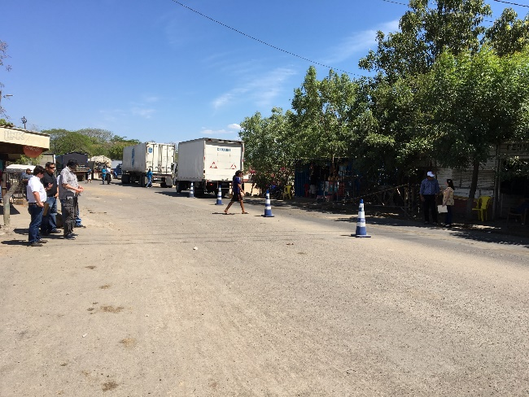

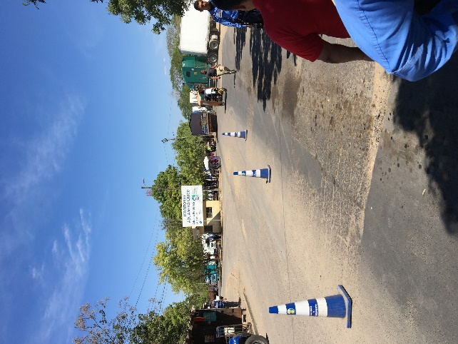

The above photos show the local building on Honduras side.

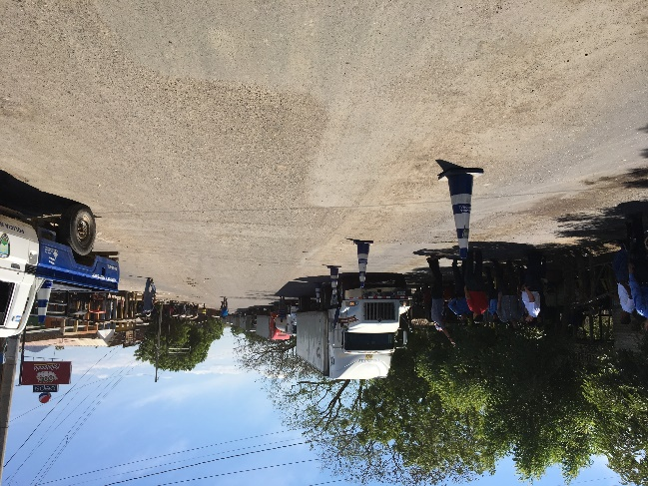

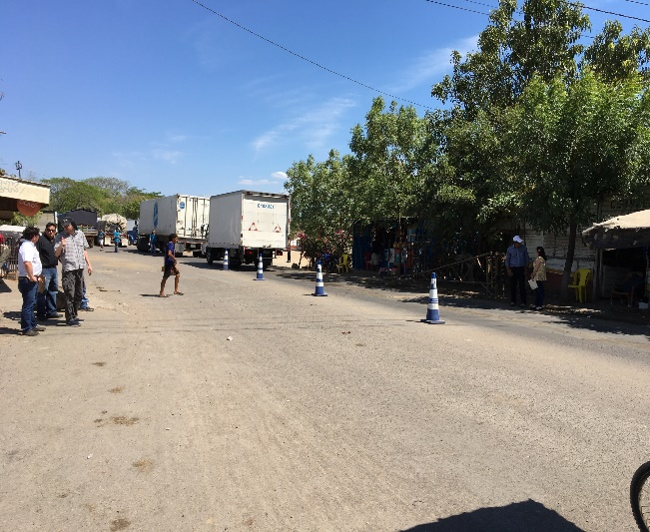

The above photos show the trucks and containers typically used.

# SITE LAYOUT AND INSTALLATION MAP

Picture below shows the locations of read points RP1 as well as the Gantry Server GS.

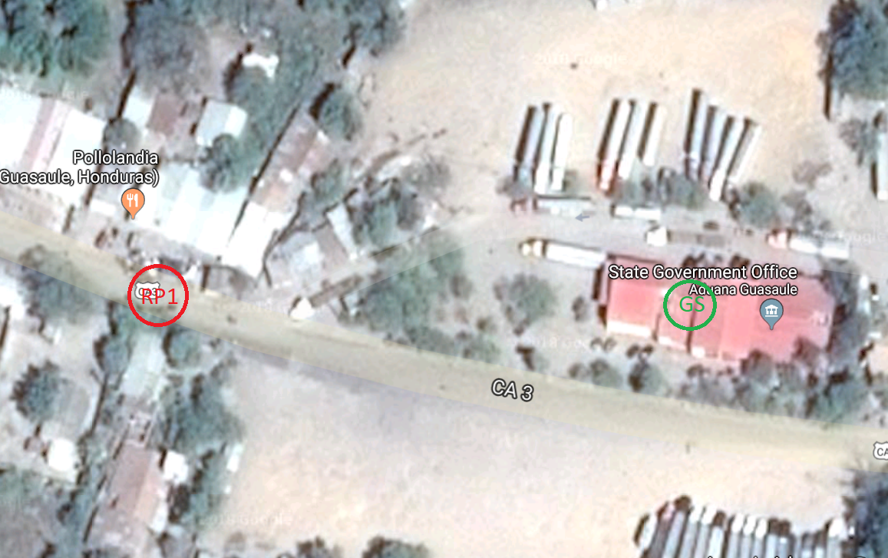

Figure 1. Satellite image showing the location for read point 1 Honduras side is on the left and Nicaragua side on the right. RP1 is located on Hwy CA3 just before the road branches.

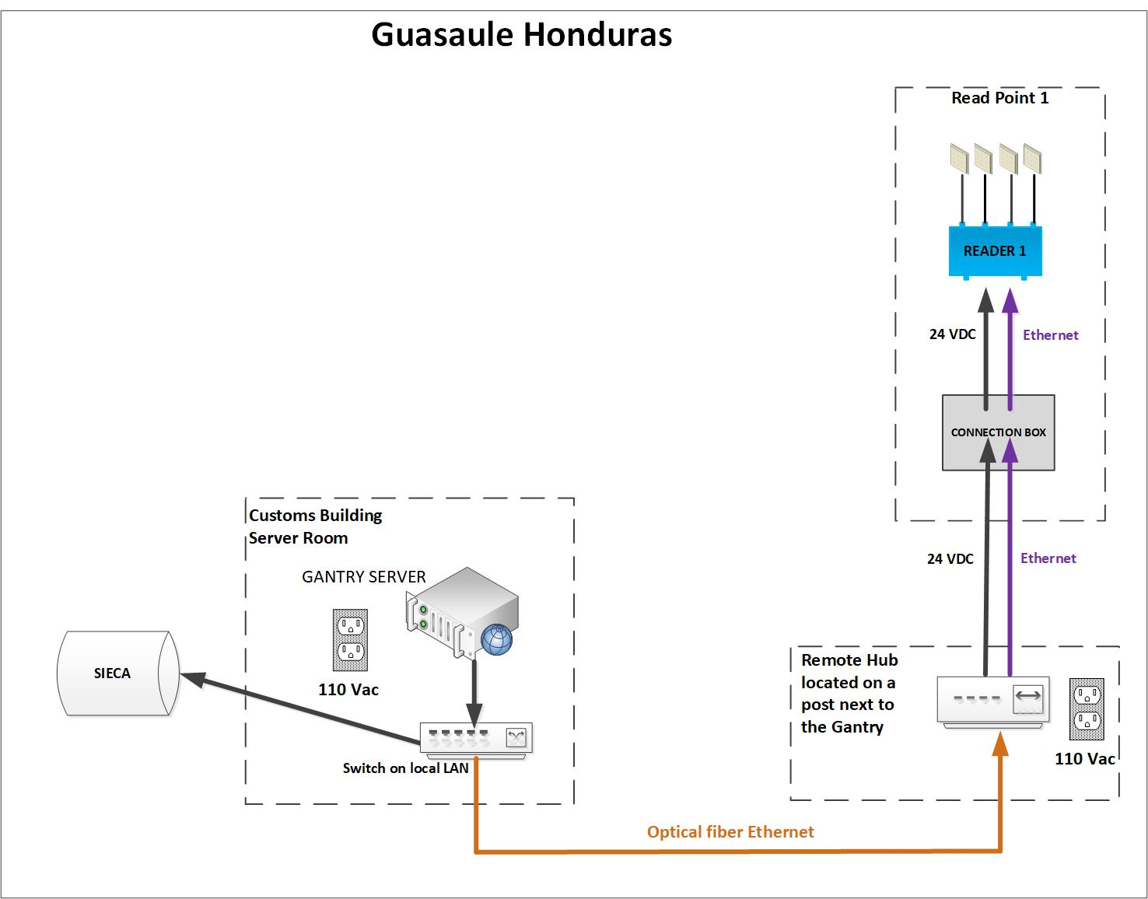

Figure 2. Guasaule Honduras installation block diagram.

## READ POINT 1

### GUASAULE HONDURAS READ POINT 1 DESCRIPTION.

This read point is located on Hwy CA3. There are two lanes of traffic. One heading towards the border with Nicaragua the other heading into Honduras after Customs and Immigration. The speed of traffic is guaranteed slow.

The RFID equipment will be mounted on the existing gantry structure that holds 2 road signs – refer to pictures below.

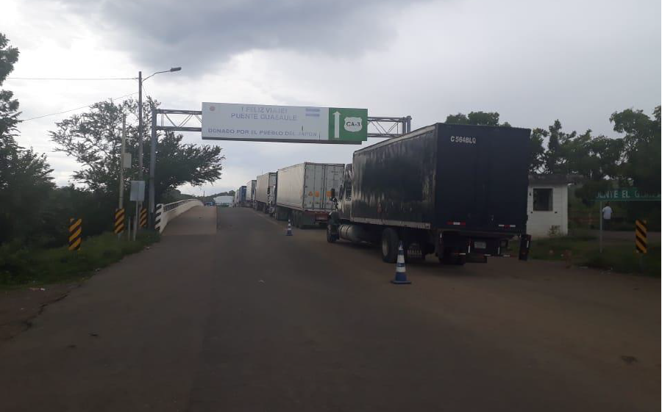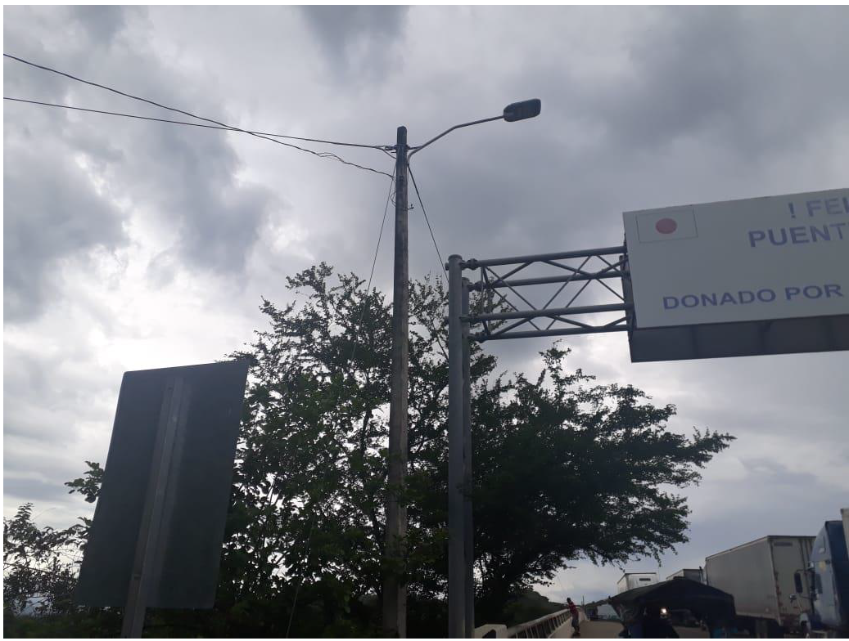

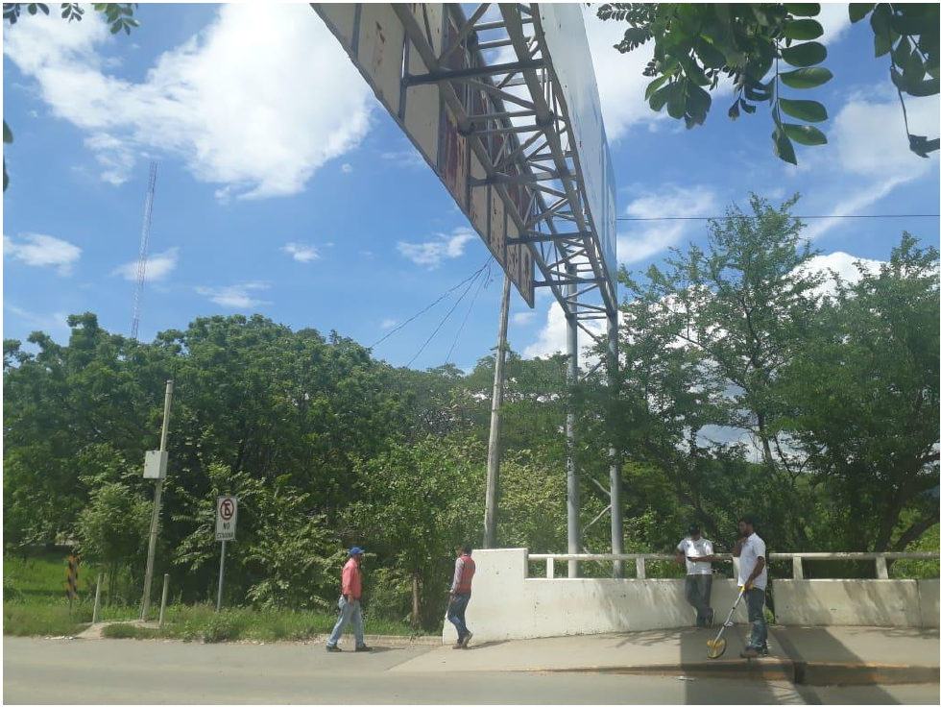

Figure 3. View of Read Point 1.

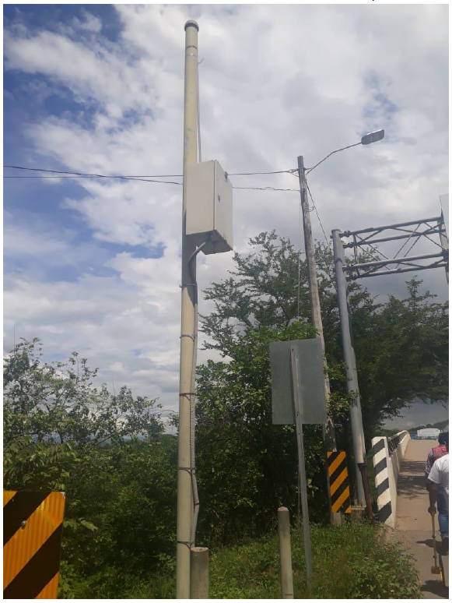

Figure 4. Remote Hub location on the pole next to existing gantry.

### GUASAULE HONDURAS READ POINT 1 GANTRY CONSTRUCTION

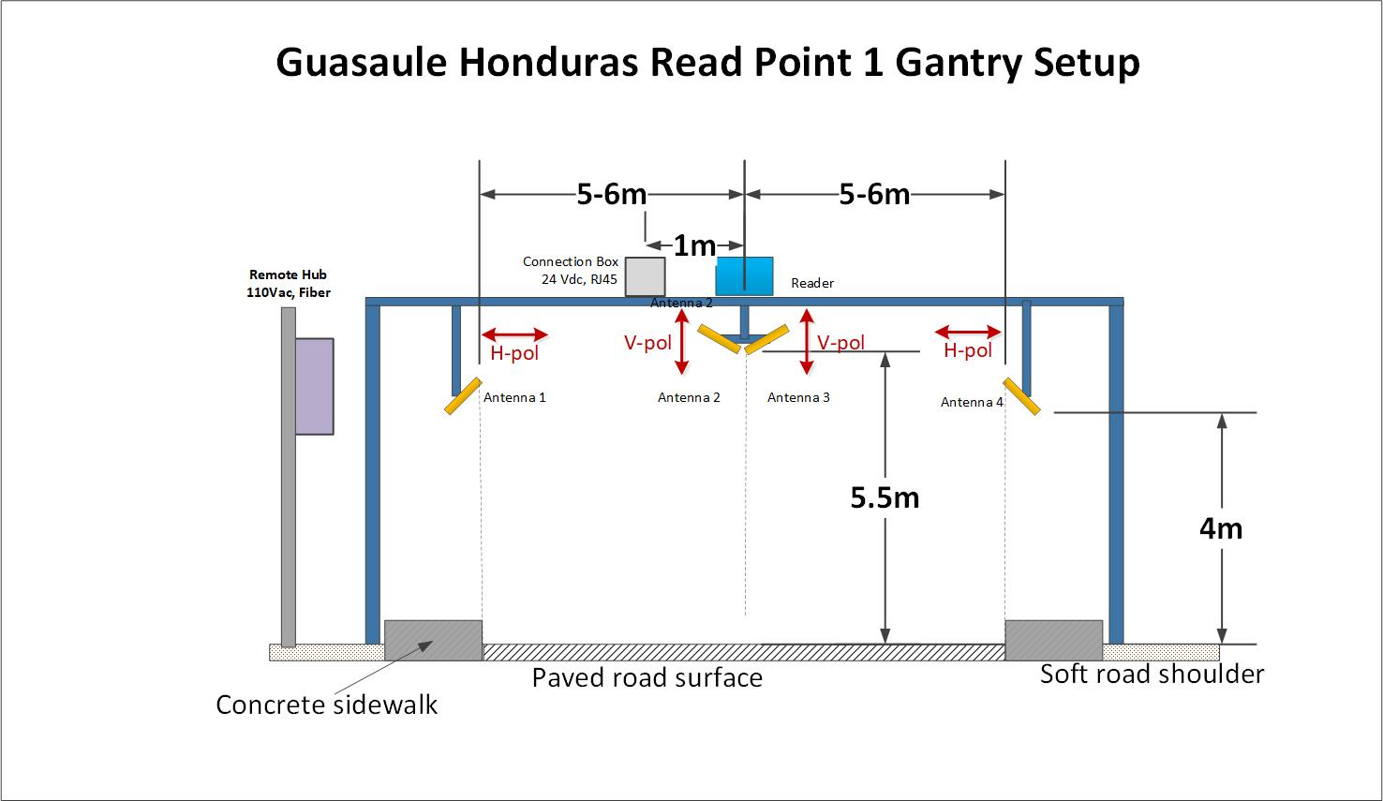

Figure 6. Sketch of the RP1 gantry setup.

To maintain proper clearances the antennas must be aligned with the permanent guards after the gantry is built.

## GANTRY SERVER

Mount Gantry Server on the wall adjacent to server in the Customs Office data center.

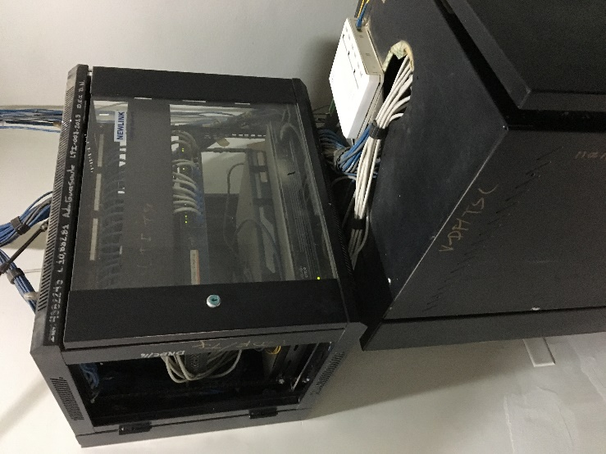 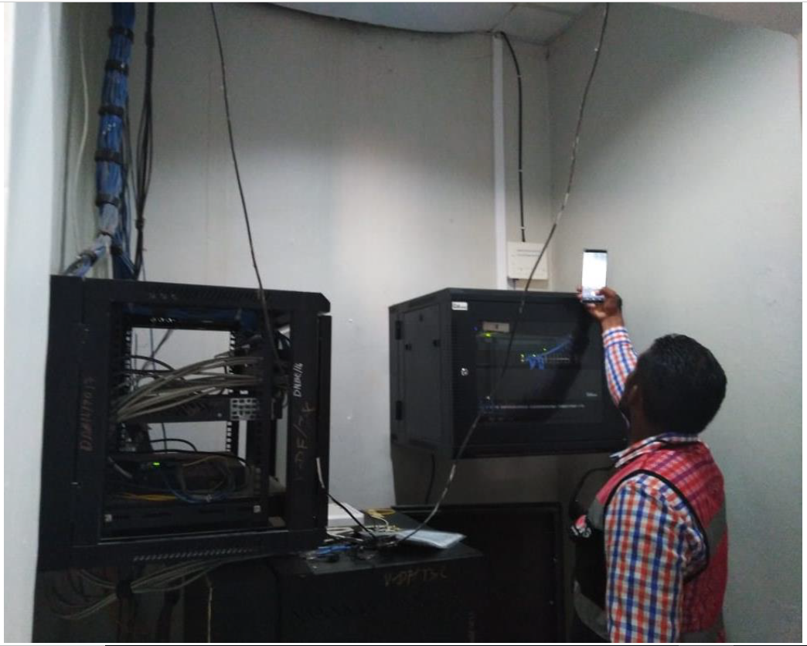

Figure 7. Server room location.

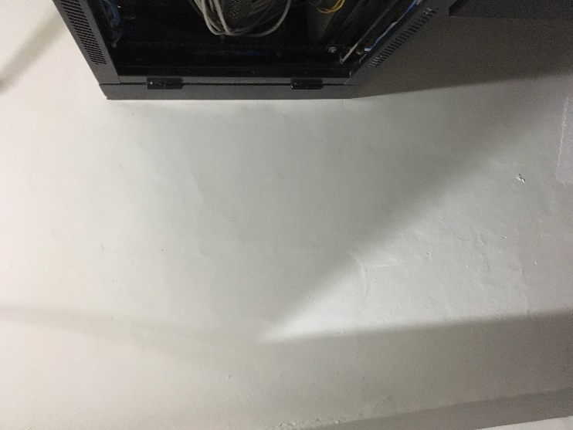

Figure 8. Location of Gantry server.

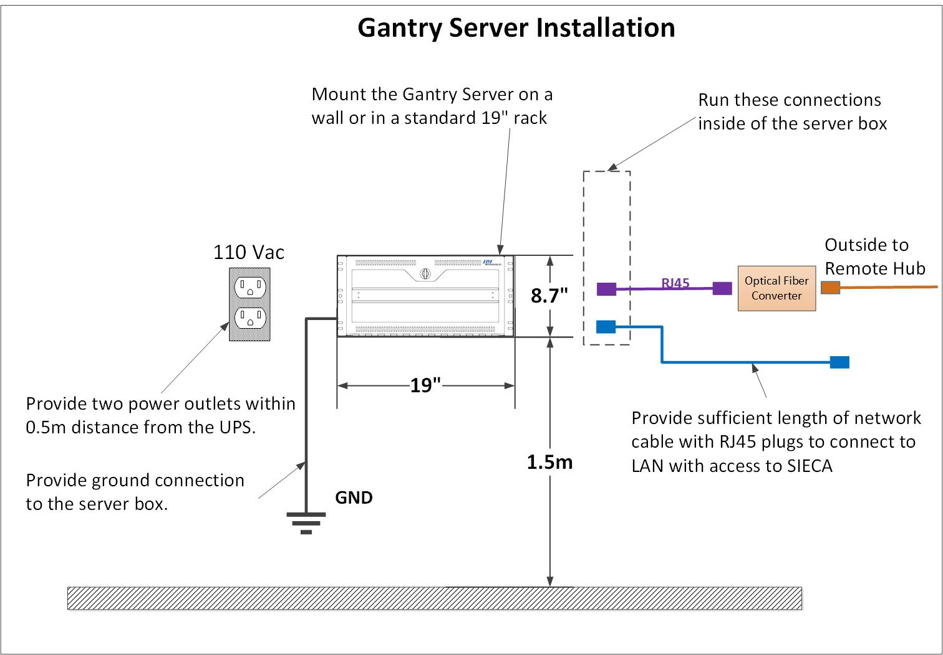

Figure 9. Gantry Server installation diagram.

* The power socket must be USA Type B. Maximum load on the 110 Vac outlet will be 150W.
* All network connections must be regular Ethernet (not POE).

# Network configuration

Consult with the Customer’s IT and fill in the table below.

|  |  |  |  |  |  |  |  |  |  |  |  |  |  |  |
| --- | --- | --- | --- | --- | --- | --- | --- | --- | --- | --- | --- | --- | --- | --- |
| **SIECA interface** | **Input** | | | | | | |  | |  | |  | |  |
| SOAP URL | <http://10.102.1.60:56840/WsAntena.asmx> | | | | | | |  | |  | |  | |  |
| WSDL |  | | | | | | |  | |  | |  | |  |
|  |  | |  | |  | | |  | |  | |  | |  |
| **Hardware Device** | **IP** | **Subnet mask** | | **Default gateway** | | **DNS 1** | **DNS 2** | | **SIECA Identifier** | | **Default direction** | |
| Guasaule Honduras Site PC | 172.16.32.27 | 255.255.255.0 | | 172.16.32.1 | | 10.102.0.20 | 172.18.74.26 | |  | |  | |
| Guasaule Honduras RP1 | 172.16.32.26 | 255.255.255.0 | | 172.16.32.1 | |  |  | | PF-004-HND | | 1:E | |
|  |  |  | |  | |  |  | |  | |  | |
|  |  | |  | |  | | |  | |  | |  | |  |
| EDECS Site Id: | HNDARAGUASAULE01 | | | | | | |  | |  | |  | |  |

# list of equipment

The table below lists the main components required for the system, together with a note of the party responsible for supply and installation of each item.

|  |  |  |  |  |
| --- | --- | --- | --- | --- |
| **#** | **ITEM** | **QTY** | **SUPPLIER** | **INSTALLER** |
| 1 | RP1 antenna cable, 9m (30ft) | 2 | Lyngsoe | TAS |
| 2 | RP1 antenna cable, 3m (10ft) | 2 | Lyngsoe | TAS |
| 5 | Gantry Reader Kit, 4 antennas | 1 | Lyngsoe | TAS |
| 6 | Gantry Server Kit | 1 | Lyngsoe | TAS |
| 7 | Gantry Connection Box | 1 | TAS | TAS |
| 8 | Data connection: Gantry Server to local LAN (SIECA) | 1 | TAS | TAS |
| 9 | 110 Vac power connection (2 outlets) for Gantry Server | 1 | TAS | TAS |
| 10 | 24Vdc power cable from Gantry Server to RP1 Connection Box | 1 | TAS | TAS |
| 11 | Ethernet cable from Gantry Server to RP1 Connection box | 1 | TAS | TAS |
| 12 | Remote Hub Kit | 1 | Lyngsoe | TAS |
| 13 | Optical fiber cable from Gantry Server to Remote Hub (appr 280m) | 1 | TAS | TAS |
| 14 | Fiber media converter (one for Gantry Server, one for Remote Hub) | 1 | TAS | TAS |
| 15 | Remote Hub NEMA enclosure | 1 | TAS | TAS |
| 16 | 110 Vac power connection (2 outlets) for Remote Hub | 1 | TAS | TAS |
| 17 | Drop down bars for antenna mounting | 4 | TAS | TAS |
| 18 | Bracket for reader mounting | 1 | TAS | TAS |

# Scope of installation work for TAS

|  |  |  |
| --- | --- | --- |
| **Scope of work for TAS:** | | |
| **#** | **Guasaule Honduras  Services** | **QTY** |
| 1 | Installation  Reader Points - 4 Antennas, 1 Reader, 1 Connection Boxe | 1 |
| 2 | Supply and Installation of 24VDC cable from Remote Hub to RP1 via Connection Box | 1 |
| 3 | Supply and Installation of Ethernet cable from Remote Hub to RP1 via Connection Box | 1 |
| 4 | Supply and Installation of Remote HUB NEMA Box with optical fiber media converter, 2x 110VAC outlets and Remote Hub kit. The Remote Hub Kit (24Vdc power supply, Ethernet Switch) is provided by Lyngsoe. | 1 |
| 5 | Supply and Installation of 110VAC energy cable from (?) to Remote Hub. The service includes Electrical Box, Meter, Breakers and cable, 2 outlets connected inside Remote Hub NEMA box located in Guard House. | 1 |
| 6 | Supply and Installation of 280meters of Core Fiber Optic from Server Room to Remote HUB (includes, fiber, fiber accessories, media converters 10/100/1000 mounted 1st near Gantry Server and the 2nd inside Remote Hub NEMA box) | 1 |

# CHECKLIST

|  |
| --- |
| After the installation work has been completed, please sign and return this Site Survey Checklist to:  Lyngsoe Systems  Fax No.: +45 98 622 394  E-mail: [jbo@lyngsoesystems.com](mailto:jbo@lyngsoesystems.com)  Att.: Mr. Jesper Boller  From: ________________________________________________________________  (Name and administration)  **______________ ______________________________________________**  **(**Date**) (**Signature**)** |
|  |

|  |  |  |  |
| --- | --- | --- | --- |
| **The following installation work has been completed:** | | | |
| **#** | **JOB** | **PARTY RESPONSIBLE** | **SIGN WHEN FINISHED** |
| 1 | VPN is available to Lyngsoe for remote access to the Gantry Server. | SIECA |  |
| 2 | Static IPs for Gantry Server Computer, GS Ethernet Switch, Remote Hub Switch, Remote Hub UPS, RP1 are assigned on the network (fill network configuration table) | SIECA |  |
| 3 | Gantry Server and accessories are installed in the server room. | TAS |  |
| 4 | Power to the Gantry Server box installed. | TAS |  |
| 5 | Gantry Reader Kit is installed at RP1 | TAS |  |
| 6 | Take note of the IP address of each reader (labeled on the enclosure) and at which RP that reader is located. | TAS |  |
| 7 | Connection Box installed at RP1 | TAS |  |
| 8 | Remote Hub is installed and connected | TAS |  |
| 9 | 24Vdc Power and Ethernet communication lines are installed between Remote Hub and RP1 via Connection Box. | TAS |  |
| 10 | Site Configuration is performed on the Gantry Server Computer. Proper IP addresses are assigned to all units. | Lyngsoe |  |
| 11 | Installation (pre-site acceptance testing) tests are performed and passed | Lyngsoe and SIECA |  |

Technical enquiries about the above installation work should be addressed to:

Lyngsoe Systems Ltd.

101 Simona Dr, Unit 2

Bolton, L7E 4E8, Ontario, Canada

Att: Mr. Oleg Iagounov and Robert Grant

Tel: +1 905 501 1533 +1 647 336-2395

E-mail: [oia@lyngsoesystems.com](mailto:oia@lyngsoesystems.com), rgr@lyngsoesystems.com

Direct +1 416 453 4054

# GUASAULE HONDURAS completed INSTALLATION

## Read Point 1 Installation

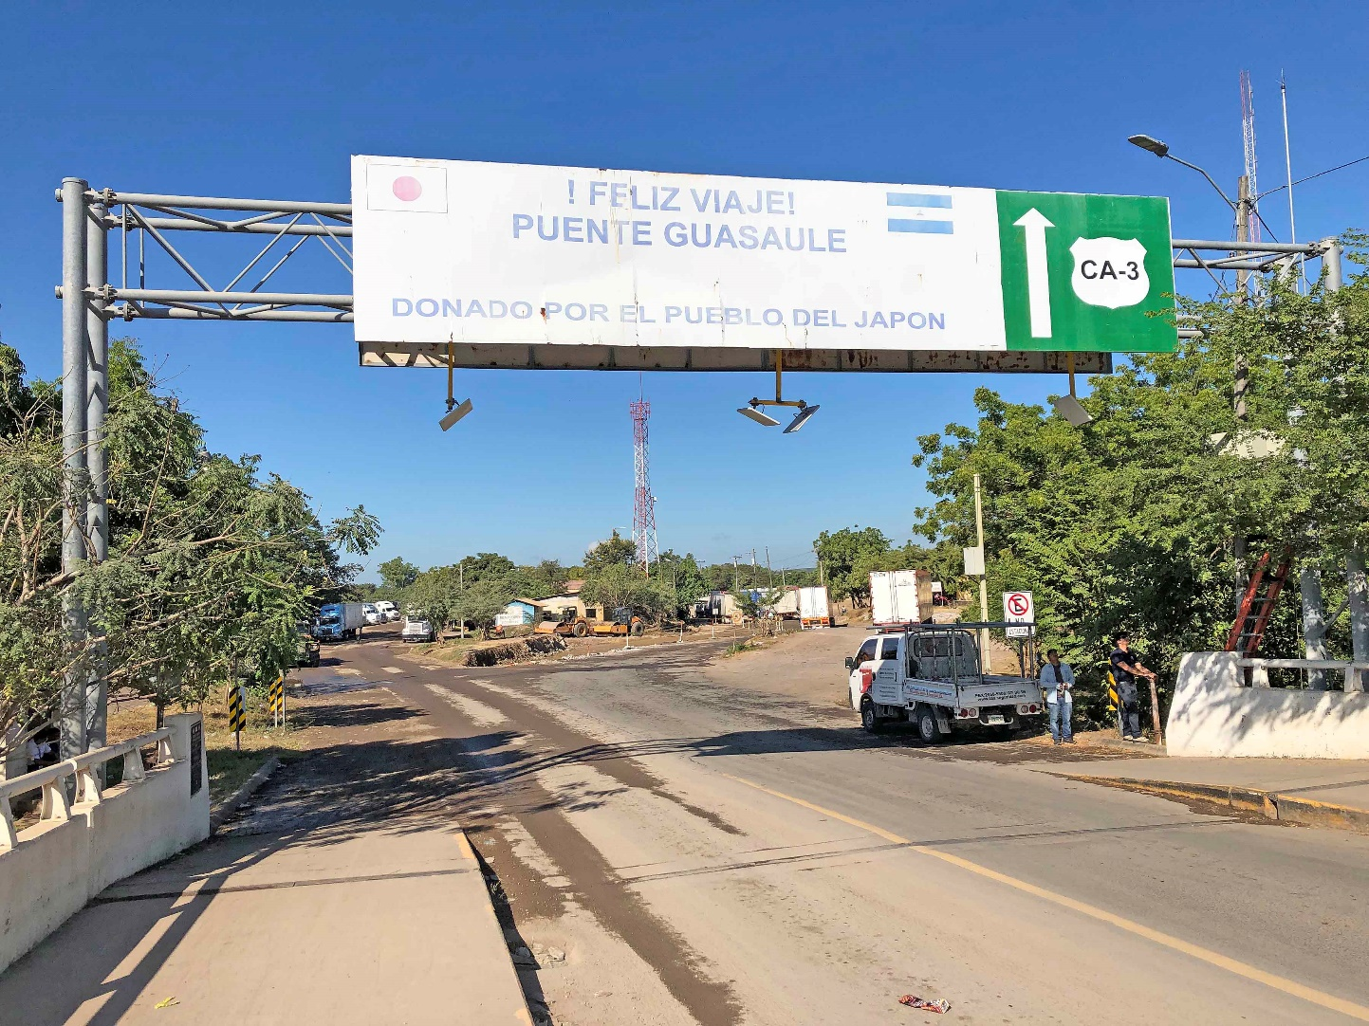

Figure 4. RP1 antennas installation.

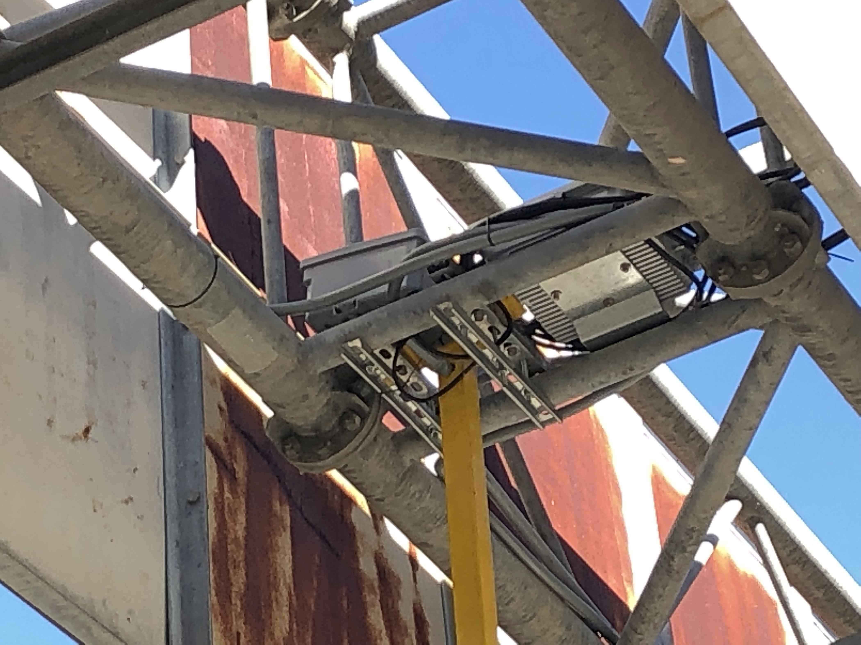

Figure 5. RP1 Reader installation.

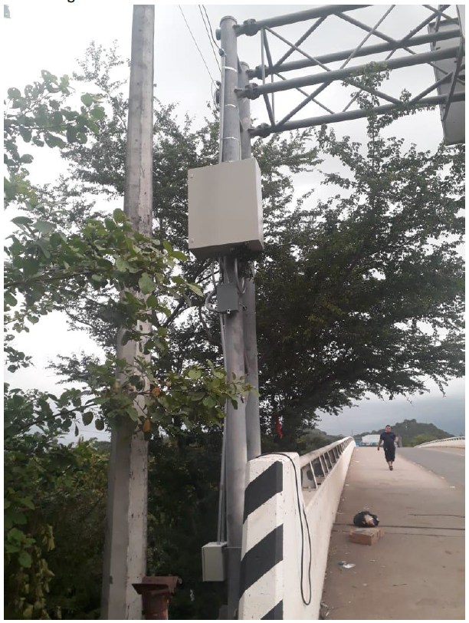

Figure 6. RP1 Remote Hub installation.

## Gantry Server Installation

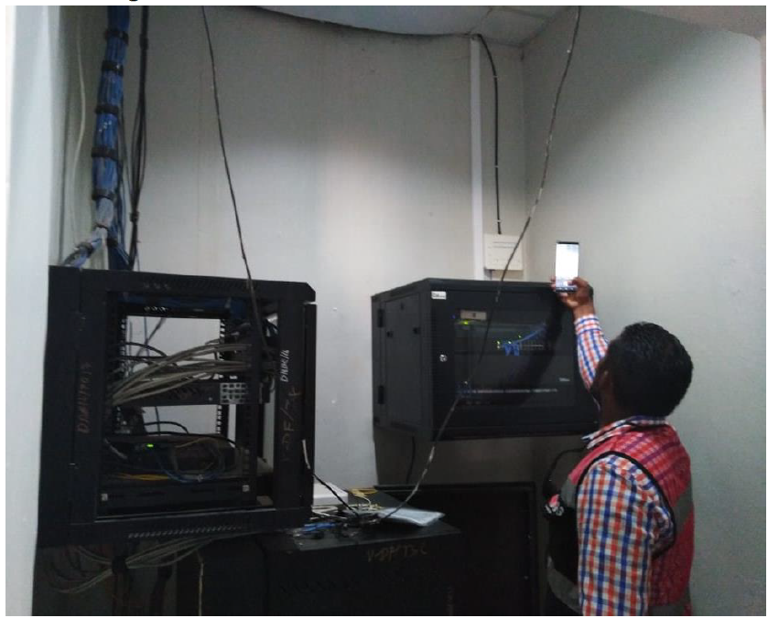

Figure 7. Gantry Server installation.

# Appendix A: notes and comments